ASSIGNMENT-7.2
Course: AI Assisted coding
Name: Ch.Shreevidya
HT NO: 2403A51419
Batch- 16
#Task1: 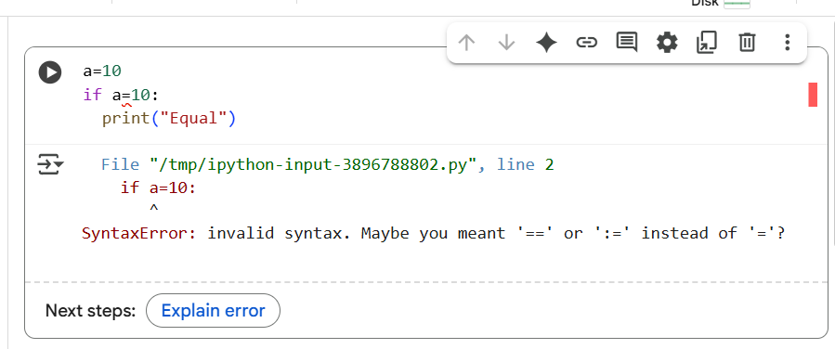
Explanation of error:
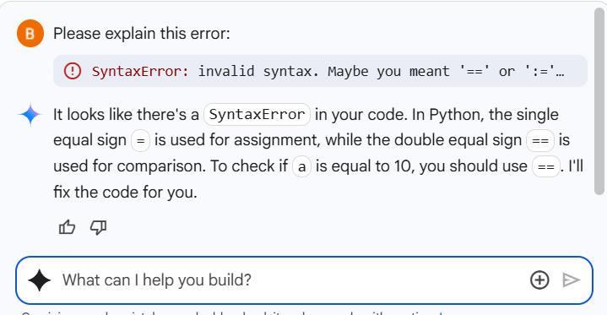

Corrected code:
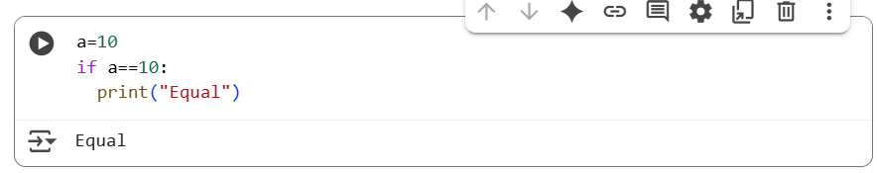
#Task 2:
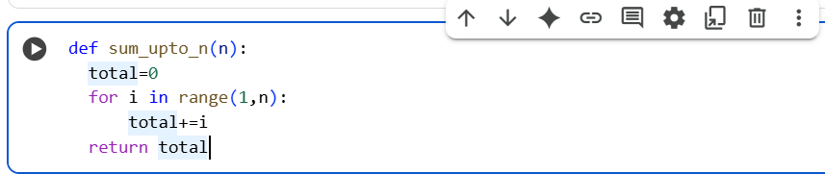
Explanation of error:
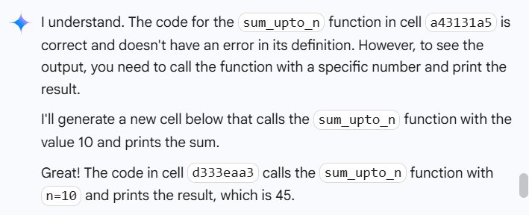
Corrected code:
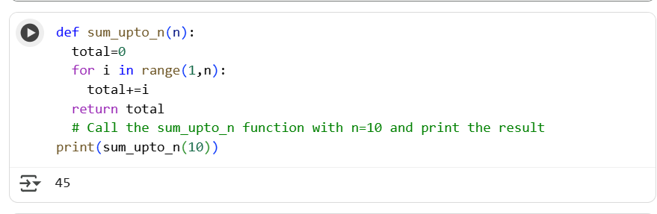
#Task 3:
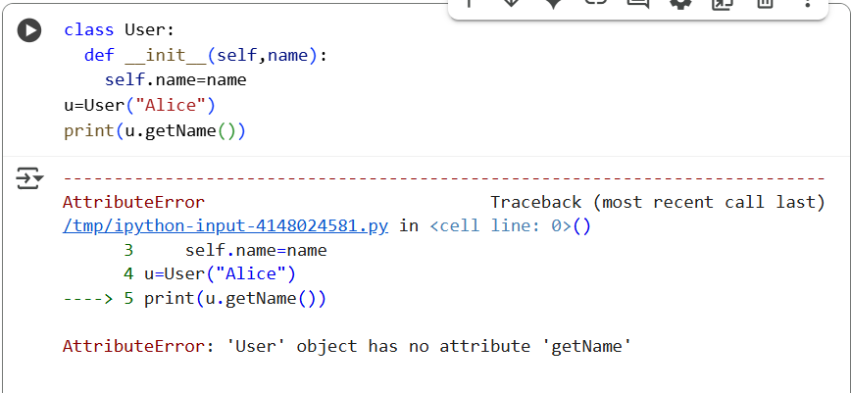
Explanation of error:
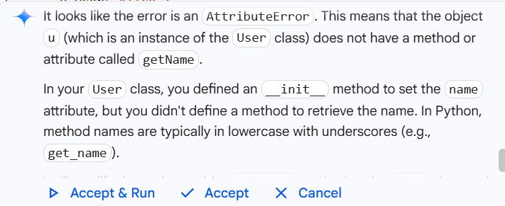
Corrected code:
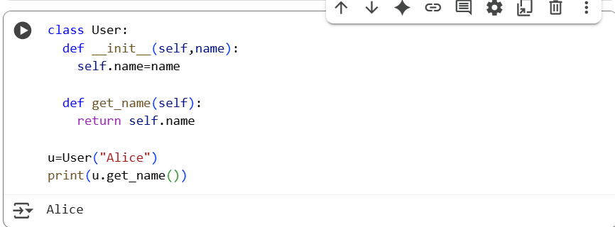
#Task 4:
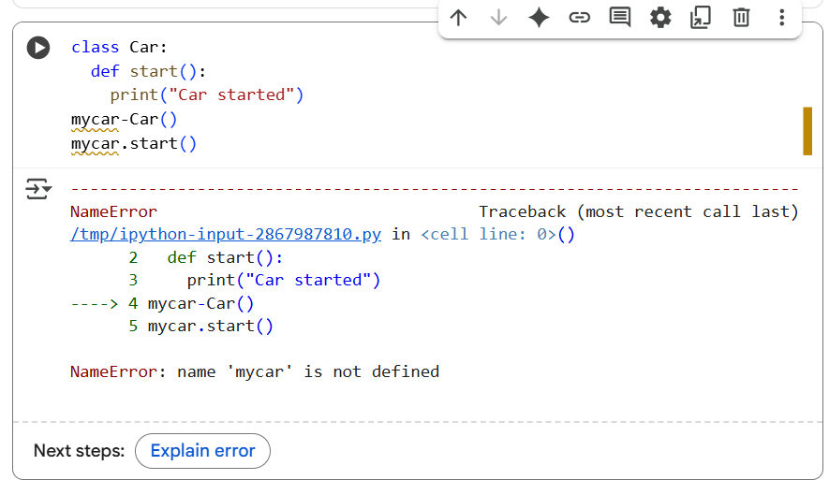

Explanation of error:
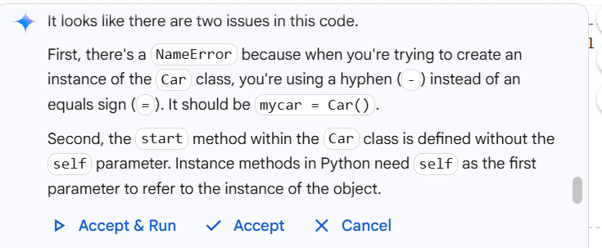
Corrected code:
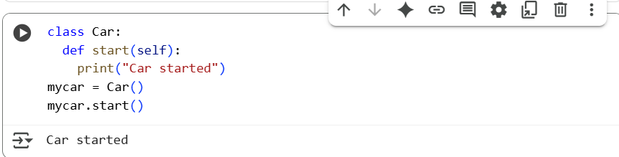
#Task 5:
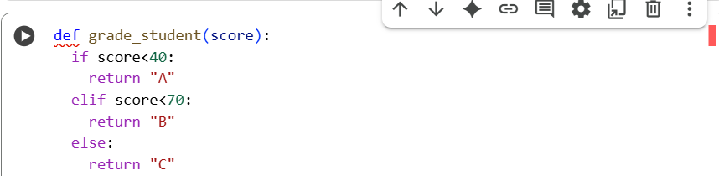

Explanation of error:
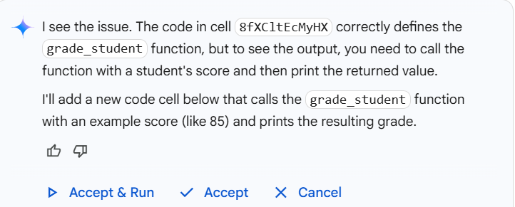
Corrected code:
